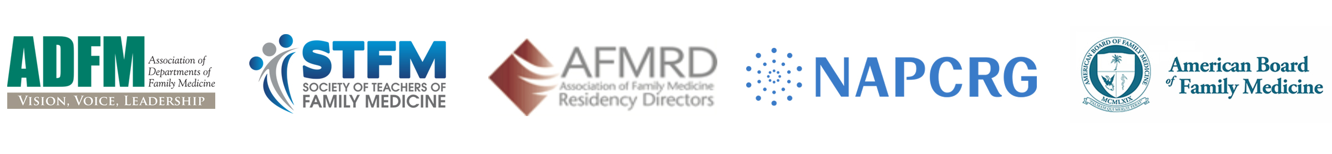

URGENT ACTIONS TO REDUCE THE SPREAD OF COVID-19
ACADEMIC FAMILY MEDICINE ORGANIZATIONS’ POLICY STATEMENT
March 27, 2020

As academic family physician leaders charged with protecting the health of individuals, families and communities across the United States, we believe a strategy of “stay at home” is imperative in all 50 states to prevent grossly excessive loss of life due to the Covid-19 pandemic. We urge the nation to do three things:

- All jurisdictions that have not already done so should issue an immediate four-week "stay at home" order, with need assessed on a regular basis and with the potential to extend as needed. Only essential businesses should be open (e.g. food, pharmacy, transportation, healthcare), and the public should be allowed to leave home only to go to those essential businesses or for recreation with 6 feet distancing.

We recognize the extraordinary hardship these measures create for so many, and we also recognize the grave danger from failing in our duty to dramatically reduce the spread of this novel virus as directed by physicians, scientists, epidemiologists, and the CDC. While there are major financial implications with a “stay at home” order, the health consequences and associated financial calamity associated with loosening social restrictions too soon would likely be much worse and could result in much longer periods of social restrictions. These restrictions should not be removed until infection rates are reduced sufficiently – possibly as long as 1-3 months, but certainly not before late April.

- Training and deploying a cadre of individuals capable of performing case finding and contact tracing, supported by public dollars, and dramatically increase access to testing is an urgent need.

- Provision of sufficient Personal Protective Equipment (PPE) is an urgent need for our health care and public health workforce necessary to do their jobs safely and to avoid quarantines of large numbers of valuable health care personnel. The Defense Production Act should be deployed immediately to make this happen.

As family physicians, we are committed to caring for our patients and communities based on the best available scientific evidence. The evidence is clear. We can end this pandemic, get back to work, and get our kids back to school most quickly if we go to war against this virus with full force. Full force means deploying “stay at home” for at least the next four weeks, broadening testing, engaging in meticulous contact tracing, and providing adequate PPE to healthcare and public health personnel. Let’s all get to work in making this happen.

